**Meriskill Virtual Data Analysis Internship**

**Day 2 Task: Profitability Calculation**

**Intern Name: Pelumi Adebisi**

**Objective**

The objective of this analysis is to assess the financial performance of various marketing campaigns by calculating profitability metrics. Specifically, the task involved computing the total profit and user acquisition by campaign, then deriving the average profitability per user.

**Methodology**

Tools Used:

* Python (Pandas, Matplotlib) for data manipulation, profitability calculation and visualization.
* Excel for charting and additional data validation.

Steps Followed:

1. Calculated Profit per transaction using:

**Profit = (Product Price – Product Cost) * Order Quantity**

1. Aggregated total profit and number of unique users acquired by ***AcquisitionSource***
2. Computed average profitability per user:

**Profitability per User = Total Profit / Number of User Acquired**

1. Analyzed the resulting profitability data to identify high performing campaigns and outliers.
2. Created visualizations for clear presentation of trends and comparative performance.

**Results**

|  |  |  |  |
| --- | --- | --- | --- |
| AcquisitionSource | Total_Profit ($) | Users_Acquired | Profitability_per_User ($) |
| Google-ads | 8328057.02 | 16658 | 499.94 |
| Meta-ads | 1079291.41 | 4731 | 228.13 |
| Yt-Campaign | 1039928.37 | 4756 | 218.66 |

**Top campaign by profitability per user:** Google-ads

**Notable Observation:**

Google-ads campaign outperformed the others by over 100% in profitability per user, suggesting efficient targeting and conversion.

**Visualization**

Figure 1: Profitability per User by Acquisition Source

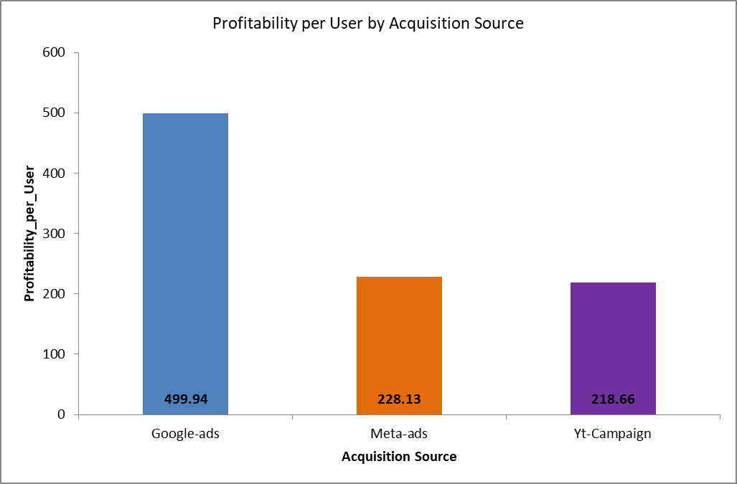

**Conclusion**

The profitability analysis showed key insights into the financial effectiveness of each marketing campaign. Meta-ads and YouTube(Yt)-Campaign both underperformed in profitability, compared to Google-ads. Google-ads campaign profitability indicates efficient customer acquisition and transaction margins.